**3. Install kubectl CLI**

--- **IMPORTANT NOTE**: Kubectl binaries for EKS please prefer to use from Amazon (Amazon EKS-vended kubectl binary)

--- This will help us to get the exact Kubectl client version based on our EKS Cluster version. You can use the below documentation link to download the binary.

--- **Reference:** <https://docs.aws.amazon.com/eks/latest/userguide/install-kubectl.html>

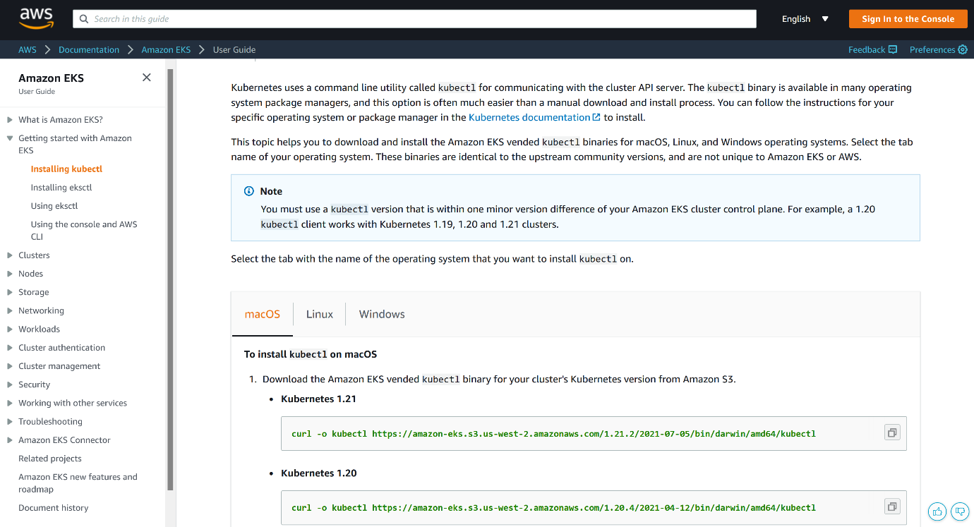

--- note – based on operating system your using, you can download the kubectl from this page.

**Install and configure kubectl on MAC**

--- **note** - Kubectl version we are using here is 1.16.8 (It may vary based on Cluster version you are planning use in AWS EKS)

**# Download the Package**

--- **mkdir kubectlbinary**

--- **cd kubectlbinary**

--- **curl -o kubectl https://amazon-eks.s3.us-west-2.amazonaws.com/1.16.8/2020-04-16/bin/darwin/amd64/kubectl**

**# Provide execute permissions**

--- **chmod +x ./kubectl**

**# Set the Path by copying to user Home Directory**

--- **mkdir -p $HOME/bin && cp ./kubectl $HOME/bin/kubectl && export PATH=$PATH:$HOME/bin**

--- **echo 'export PATH=$PATH:$HOME/bin' >> ~/.bash_profile**

**# Verify the kubectl version**

--- **kubectl version --short --client**

Output: Client Version: v1.16.8-eks-e16311

**Install and configure kubectl on windows**

--- **mkdir kubectlbinary**

--- **cd kubectlbinary**

--- **curl -o kubectl.exe https://amazon-eks.s3.us-west-2.amazonaws.com/1.16.8/2020-04-16/bin/windows/amd64/kubectl.exe**

**Update the system Path environment variable**

--- **C:\Users\KALYAN\Documents\kubectlbinary**

**Verify the kubectl client version**

--- **kubectl version --short --client**

--- **kubectl version --client**